**ExpenseFlow: Expense Request Approval Automator Name: Shaik Javeed Ahammad**

**Phase 2: Org Setup & Configuration**

**1. Salesforce Org Creation**

* Signed up for a free Salesforce Developer Edition org to serve as the primary development and testing environment.
* Verified login and navigation to the **Setup** menu.

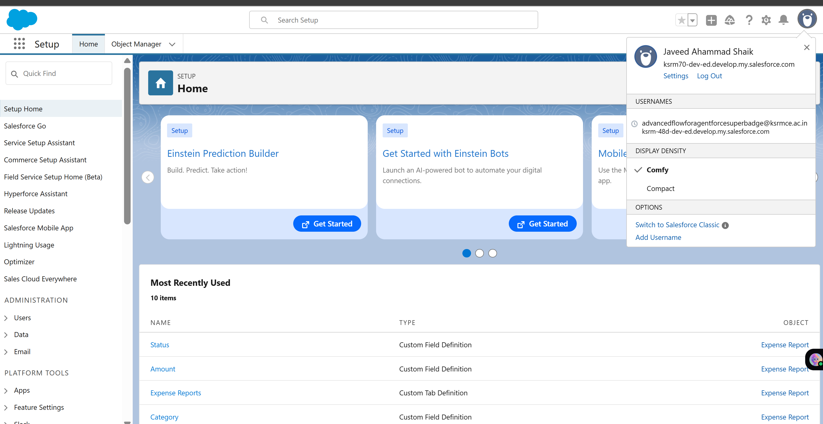-

**2. Company Profile Setup**

* Updated the Company Name to *ExpenseFlow: Expense Request Approval Automator*.
* Configured the **Time Zone** to (GMT+05:30) India Standard Time.
* Set the **Default Currency** to INR – Indian Rupee (₹).

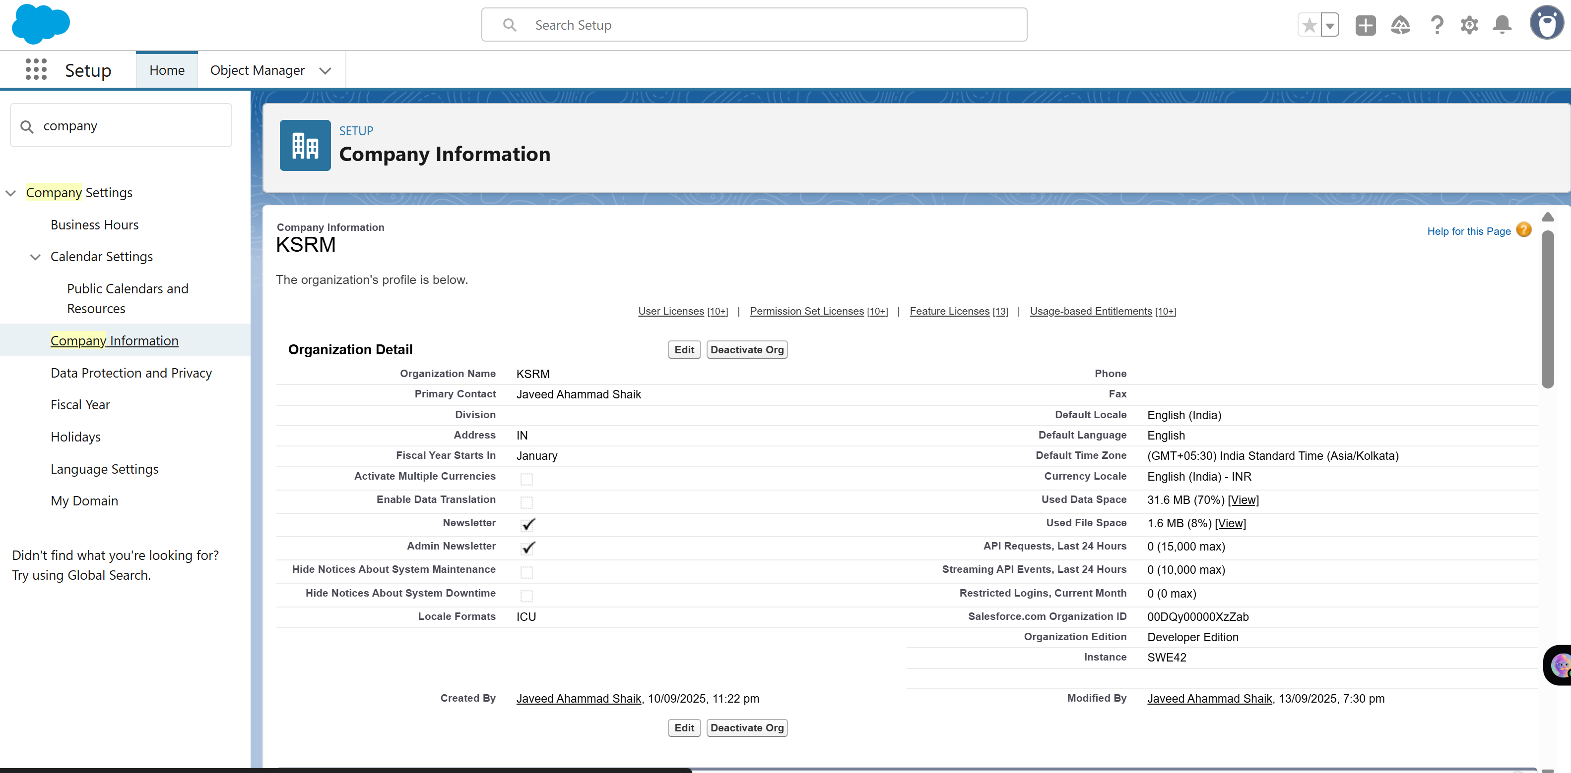

**3. Business Hours & Holidays**

* Created a new business hours set named **Expense Approval Hours**, covering 12:00 AM to 12:00 AM.
* Added key organizational holidays (e.g., Independence Day, Republic Day) for accurate approval timelines.

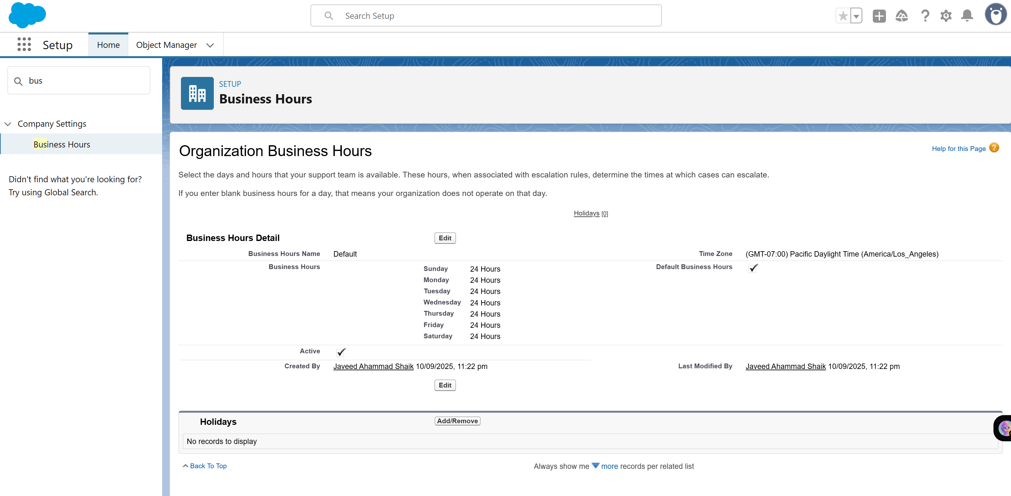

**4. Fiscal Year Settings**

* Selected the **Standard Fiscal Year**, starting in January.
* Ensures financial reports and dashboards align with the calendar year (Jan–Dec).

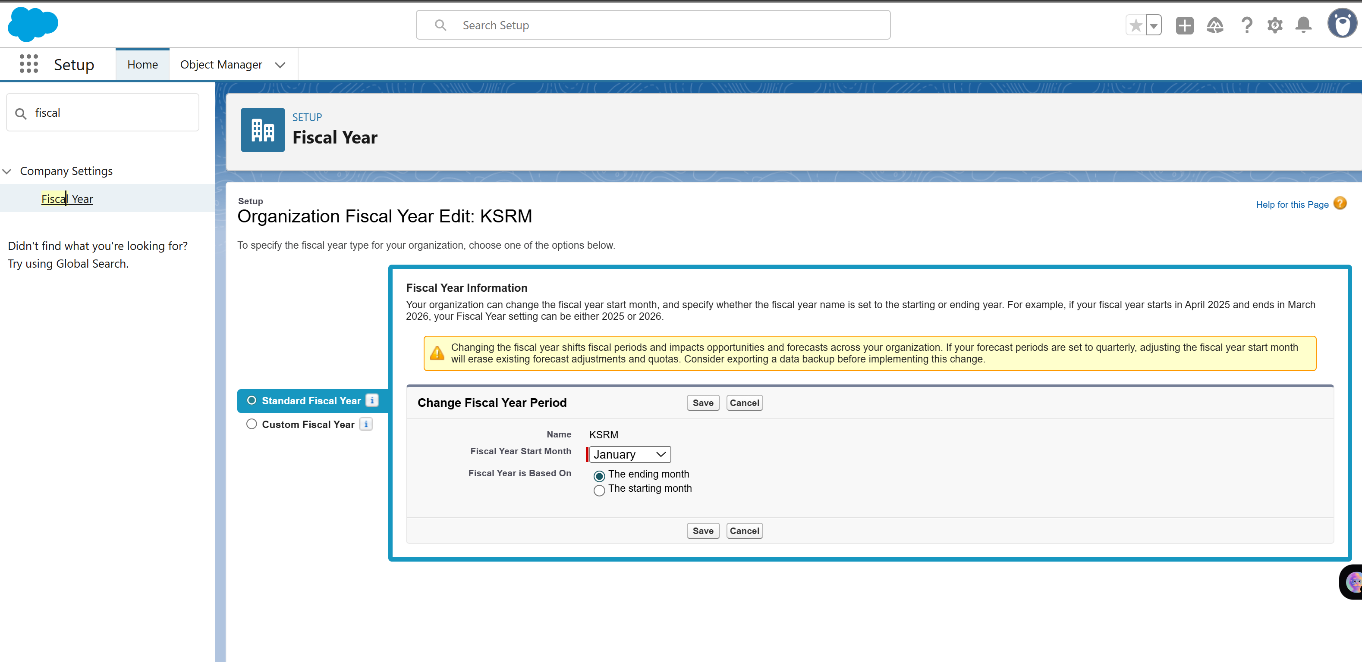

**5. User Setup & Licenses**

* Created three test users for role-based scenarios:
  + **Admin User**: Full system access and configuration.
  + **Manager User**: For approving employee expense requests.
  + **Employee User**: For submitting expense requests.
* Assigned Salesforce licenses to each user and mapped them to their respective roles.

**6. Profiles**

* Customized profiles based on responsibilities:
  + **Employee Profile**: Granted *Read, Create, and Edit* permissions on the Expense Request and Expense Item objects
  + **Manager Profile**: Granted *Read, Create, Edit, and Approve* permissions, with visibility to employee records.
  + **Admin Profile**: Full system access (default).

**7. Roles**

* Established a role hierarchy:
  + **Manager → Employee**
* This ensures managers can view and approve records created by employees reporting to them.

**8. Permission Sets**

* Created permission sets for flexibility:
  + **Expense Request Submitter**: Grants additional create permissions for employees.
  + **Expense Approver**: Grants approval-related permissions for managers.

**9. Org-Wide Defaults (OWD)**

* Configured default record access:
  + Expense Request = **Private**
  + Expense Item = **Controlled by Parent**
  + User = **Private**

**10. Sharing Rules**

* Implemented role-based sharing:
  + **Manager Access**: Managers automatically gain read/write access to their team’s Expense Requests.
  + **Finance Collaboration**: Sharing rule to allow finance role users to view and update all expense requests for auditing.